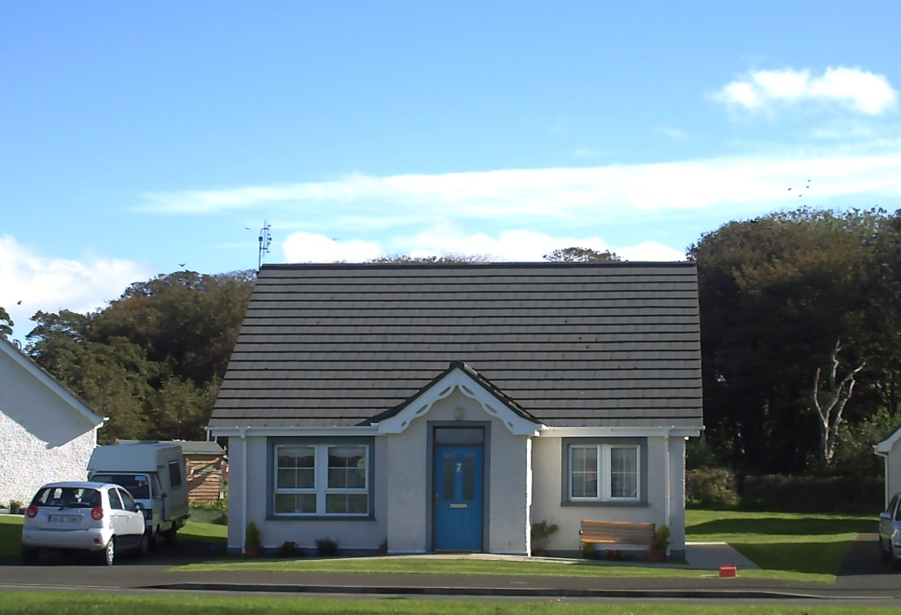
Two Bedroom Homes
- Traditional cottage styled homes
- Open view at front to bay and beyond
- Level access throughout
- Thermally well insulated
- Connected to centralised heating system
- Emergency call alarm provided
- Parking space beside most homes
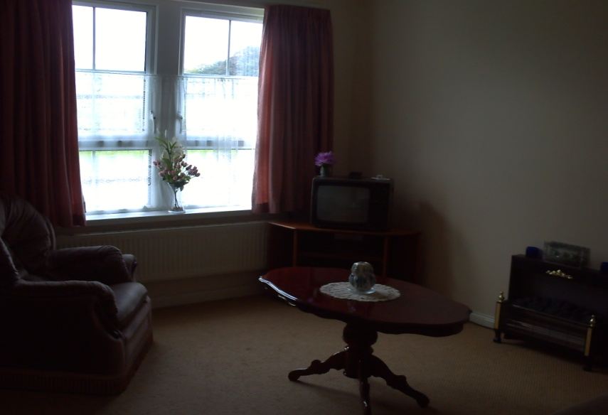
Living Room
- Provides an area to relax & watch TV,* or the world go by
- Convenient to front door for visitors calling

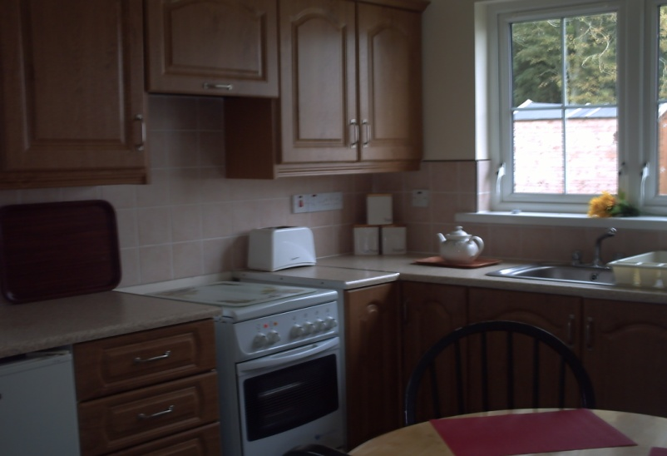
Kitchen
- Range of high and low level cupboards
- Space for a slot in cooker, fridge & washing machine*
- Separate from living room

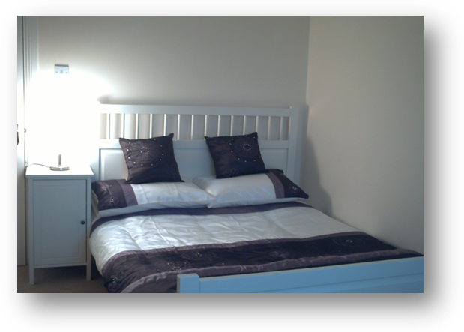
Bedrooms
- Two light and airy bedrooms
- Ample power outlets
- Views of woodland to rear

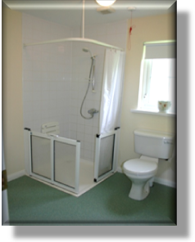
Bathroom
- Level access shower
- W.C
- Wash hand basin

* No furniture or appliances are provided

